Cynthia Persinger

2629 Glenchester Rd

Wexford, PA 15090

[persinger@calu.edu](mailto:persinger@calu.edu)

Schapiro, Meyer (1904-1996) Word Count: 464

The Lithuanian-born, American art historian Meyer Schapiro was born in Šiauliai (Shavley), Lithuania, on September 23, 1904, but soon emigrated to the United States with his family in 1907. Schapiro grew up in the working-class, left wing, Jewish immigrant neighborhood of Brownsville, Brooklyn. He graduated from Columbia University with a Ph.D. in fine arts and archeology in 1935 (having completed his dissertation in 1929). He spent his career at Columbia, though he also taught regularly at the New School for Social Research from 1936 until 1952. Although trained as a medievalist, Schapiro was an early proponent of modern art, and over the course of his career, he taught courses, lectured, and published on both. Through his lectures and publications, his ideas shaped several generations of artists and art historians. Though he published several books including those on post-Impressionist artists Paul Cézanne (1950) and Vincent van Gogh (1952), he published his most respected ideas on both medieval and modern topics in articles. Schapiro is known for his innovative and interdisciplinary approaches to art history; he explored new art historical methodologies through the use of Marxism, psychoanalysis, and semiotics. He is also known for his essay ‘Style’ (1953), a systematic consideration of past and current theories of style.

Schapiro consistently sought to understand art through the relationship between its formal characteristics and its historical meaning without resorting to racial or national characterisations of style, as his German-speaking predecessors had. Schapiro’s influences shifted over the decades. His career began in the 1930s when his essays and reviews appeared in leftist journals including *The Marxist Quarterly*, *New Masses* and *Partisan Review*. In the late 1930s and early 1940s, he had increasing contact with European exiles, including art historian Erwin Panofsky (1892-1968) and surrealist André Breton (1896-1966). In the 1950s, Schapiro’s interests extended to the social sciences. In the late 1960s, he played an active role in establishing the field of semiotics in the United States.

**References and further reading**

Craven, D. (ed.)(1994) *Oxford Art Journal*, special issue dedicated to Schapiro, 17 (1).

Persinger, C. (2010) ‘Reconsidering Meyer Schapiro and the New Vienna School’, *Journal of Art Historiography* 3. <http://arthistoriography.wordpress.com/number-3-december-2010/>

Schapiro M. (1952) *Paul Cézanne,* New York: H. N. Abrams.

----- (1950) *Vincent van Gogh*, New York: H. N. Abrams.

----- (1953) ‘Style’, *Anthropology Today: An Encyclopedic Inventory*, ed. by A. K. Krober, Chicago: University of Chicago Press, 287-312.

----- (1995) *Meyer Schapiro: The Bibliography,* New York: George Braziller.

----- (1977) *Romanesque Art,* Selected Papers I, New York: George Braziller.

------ (1977) *Modern Art: 19th and 20th Centuries,* Selected Papers II, New York: George Braziller.

----- (1979) *Late Antique, Early Christian, and Medieval Art,* Selected Papers III, New York: George Braziller.

----- (1994) *Theory and Philosophy of Art: Style, Artist, and Society,* Selected Papers IV, New York: George Braziller.

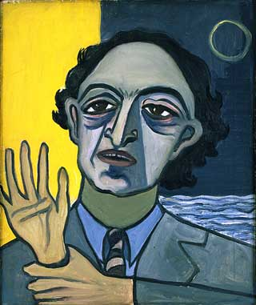

1947 Meyer Schapiro  
Oil on Canvas  
24 x 20 inches / 61 x 50.8 cm  
Private Collection

<http://www.aliceneel.com/gallery/?mode=display&category=2&painting=27>

Copyright holder: I emailed the Neel estate and was told that they had passed my name on to the David Zwirner Gallery, who would contact me about reproduction rights. I have not heard from them.